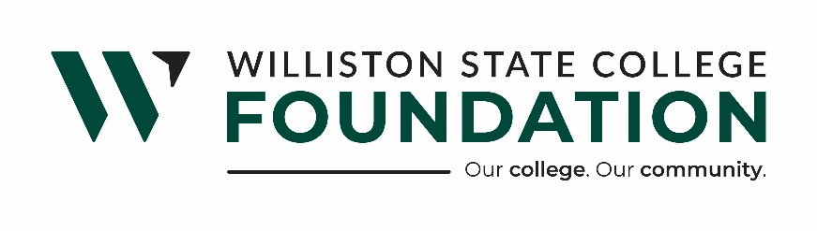

WSC FOUNDATION BOARD OF DIRECTORS REGULAR MEETING
MINUTES
721 E. HIGHLAND DR. SUITE D | March 27, 2025 |11:30 p.m.

WSC Foundation Mission Statement:

Williston State College Foundation is dedicated to advancing the college’s mission by securing financial support and fostering meaningful connections with alumni, donors, and the surrounding communities.

Present: Board Members Ward Koeser, Mark Barstad, Lee Murphy, Katie Kringen, Lance Olson, Bill Gathman, Brandon Johnson, Jackie Lee, and Taylor Olson. WSC President, WSCF Staff: Executive Director, Hunter Berg, and WSCF Donor Relations and Community Outreach Coordinator, Kristina Kitchens, Chief Financial Officer Laurie Furuseth.

Absent: Board Members: Melanie Stillwell and Jory Meyer
WSC President, Dr. Bernell Hirning
President Taylor Olson called the meeting to order at 11:34 am.

Motion to approve the Consent Agenda as follows made by Director Lance Olson and seconded by Director Lee Murphy. Motion carried.

- Consent Agenda:
- Minutes dated February 18th, 2025
- Code of Conduct Policy
- Required Reporting (Whistle Blower) Policy
- Fixed Asset/Capitalization Policy

Motion to approve the Financial Statements as follows, made by Lee Murphy and seconded by Director Bill Gathman. Motion carried.

- Financial Statements
  - Williston State College Foundation
  - WSC Supporting Foundation
  - WSC Housing LLC
  - WSC Charitable Gaming

- Updates:

Dr. Hirning, WSC President, Update
- Hunter gave a Legislative update per Dr. Hirning's request.
CFO, Laurie Furuseth Update:
- Laurie completed the online application for tax-exempt status for the Supporting Foundation again.
Donor Relations and Community Outreach Update:
- The WSC Foundation has two tables for Casino Night, as well as raffle tickets for the Bronco and welding trailers.
Hunter Berg, WSCF Executive Director, Update:
- Provided an update on the apartments.
- Challenge Grant – Update on proposed funding changes.
- Update on First International Bank & Trust’s Investment Department.
Old Business:
- None
New Business:
- The board requested Larry Grondahl come and present at a future board meeting for the 2027 Babe Ruth World Series Gaming Grant Requested the Foundation received.

Respectfully submitted,

Hunter Berg
Executive Director

